<Enter project name here>
System Design Document
Version <1.0>
mm/dd/yyyy

Total (100%)

Document Control

Distribution List
The following list of people will receive a copy of this document every time a new version of this document becomes available:
Teaching assistants:
<list names>
Customer(s): <list names>
Project team members:
<list names>

Change Summary
The following table details changes made between versions of this document:
Version | Date | Modifier | Description

Table of Contents

Document Control ii
Distribution List ii
Change Summary ii
1. Introduction 1
1.1. Purpose and Scope 1
1.2. Project Executive Summary 1
1.2.1. System Overview 1
1.2.2. Design Constraints 2
1.2.3. Future Contingencies 2
1.3. Document Organization 2
1.4. Project References 2
1.5. Definitions, Acronyms, and Abbreviations 3
1.5.1. Definitions 3
1.5.2. Acronyms 3
1.5.3. Abbreviations 3
2. System Architecture 4
2.1. System Hardware Architecture 4
2.1.1. <<Module 1>> 5
2.1.2. <<Module 2>> 5
2.2. System Software Architecture 5
2.2.1. <<Module 1>> 5
2.2.2. <<Module 2>> 5
2.3. Internal Communications Architecture 6
3. Human-Machine Interface 7
3.1. Inputs 7
3.2. Outputs 7
4. Detailed Design 8
4.1. Hardware Detailed Design 8
4.2. Software Detailed Design 8
4.2.1. Database Management Subsystem 10
4.3. Internal Communications Detailed Design 11
5. External Interfaces 12
5.1. Hardware Interface Architecture 12
5.2. Hardware Interface Detailed Design 12
5.3. Software Interface Architecture 12
5.4. Software Interface Detailed Design 13
6. System Integrity Controls 14

Introduction (15%)

Purpose and Scope
<< Insert a brief description of the purpose of the SDD. >>
<< Identify the system products to be produced, what they will do, and describe the uses for the system, including benefits, objectives and goals. This paragraph will briefly state the purpose of the system to which this document applies. It can describe the general nature of the system and summarize the history of the system development.
Include the following:
- Identify the system to be produced by name.
- Refer to and state the result of the earlier finalized needs analysis, in the form of a brief but formal expression of the customer’s problem(s). Explain what the system will and will not do to satisfy those needs.
- Describe the application of the system being specified. As a portion of this, it should describe all relevant top-level benefits, objectives, and goals as precisely as possible. >>

Project Executive Summary
<< This section provides a description of the project from a management perspective and an overview of the framework within which the conceptual system design was prepared. If appropriate, include the information discussed in the subsequent sections in the summary >>

System Overview
<< This section describes the system in narrative form using non-technical terms. It should provide a high-level system architecture diagram showing a subsystem breakout of the system, if applicable. The high-level system architecture or subsystem diagrams should, if applicable, show interfaces to external systems. Supply a high-level context diagram for the system and subsystems, if applicable. >>
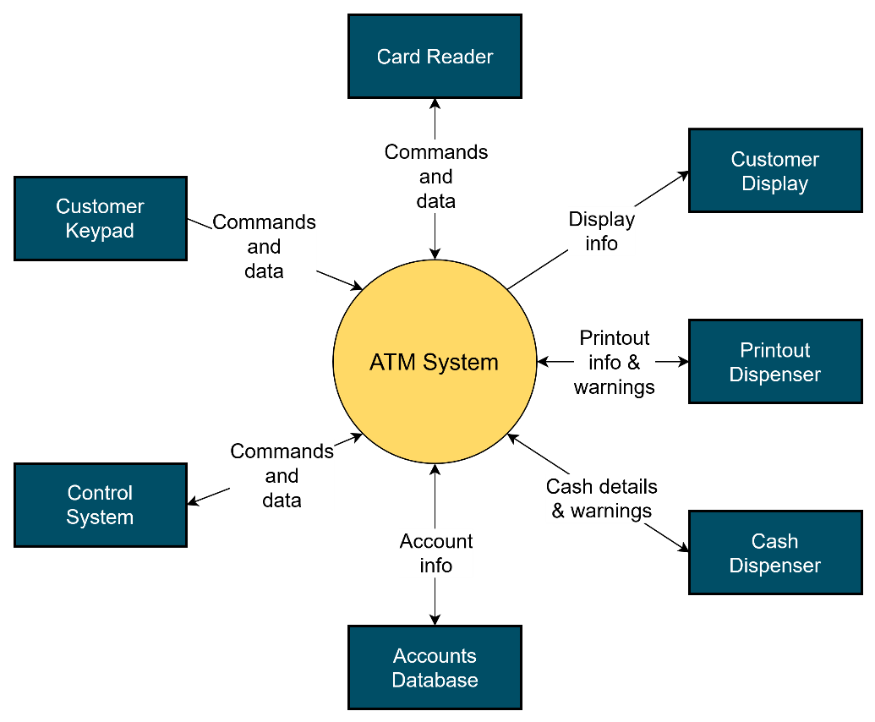
Figure 1. System context diagram

Design Constraints
<< This section describes any constraints in the system design (reference any trade-off analyses conducted, such as resource use versus productivity, or conflicts with other systems) and includes any assumptions made by the project team in developing the system design.
What operating system does the system need to run on? What is the minimum amount of RAM required to run your program, if that seems to be a limitation? List any assumptions that must be true before a user can use your system, such as needing to be connected to Wi-Fi, or the customer must have already received an ID badge >>

Future Contingencies
<< This section describes any contingencies that might arise in the design of the system that may change the development direction. Possibilities include lack of interface agreements with outside agencies or unstable architectures at the time this document is produced. Address any possible workarounds or alternative plans. >>

Document Organization
<< This section describes the organization of the System Design Document. >>

Project References
<< This section provides a bibliography of key project references and deliverables that have been produced before this point.
What type of references did you use to solve the problem? What type of references do the readers need to look at to understand the problem and your solution (you do not need to refer to technical aspect of the solution, such as UML, Python programming, etc.)? Note: some specific readers may need certain references that others don’t.
Example: airport xyz layout photos, FAA documentation, API references, etc.>>

Definitions, Acronyms, and Abbreviations
<< Supply a glossary of all terms and abbreviations used in this document. If the glossary is several pages in length, it may be included as an appendix. >>

Definitions
<< Provide a list of terms and definitions that may be required or be helpful to the intended audience. >>
This section lists terms used in this document and their associated definitions.
Table 1: <Caption>
Term | Definition
Total impulse | A measure of the overall total energy contained in a rocket motor

Acronyms
<< Provide a list of used acronyms and their associated definitions. >>
This section lists the acronyms used in this document and their associated definitions.
Table 2: <Caption>
Term | Definition
SDD | System Design Document

Abbreviations
<< Provide a list of used abbreviations and their associated definitions. >>
This section lists the abbreviations used in this document and their associated definitions.
Table 3: <Caption>
Term | Definition
e.g. | For example

System Architecture (15%)
<< In this section, describe the system and/or subsystem(s) architecture for the project. This is a high-level description of the system itself, and therefore references to external entities should be minimal, as they will be described in detail in Section 5, External Interfaces. >>

System Hardware Architecture
<< In this section, describe the overall system hardware and organization. Include a list of hardware components (with a brief description of each item) and diagrams showing the connectivity between the components. If appropriate, use subsections to address each subsystem. >>
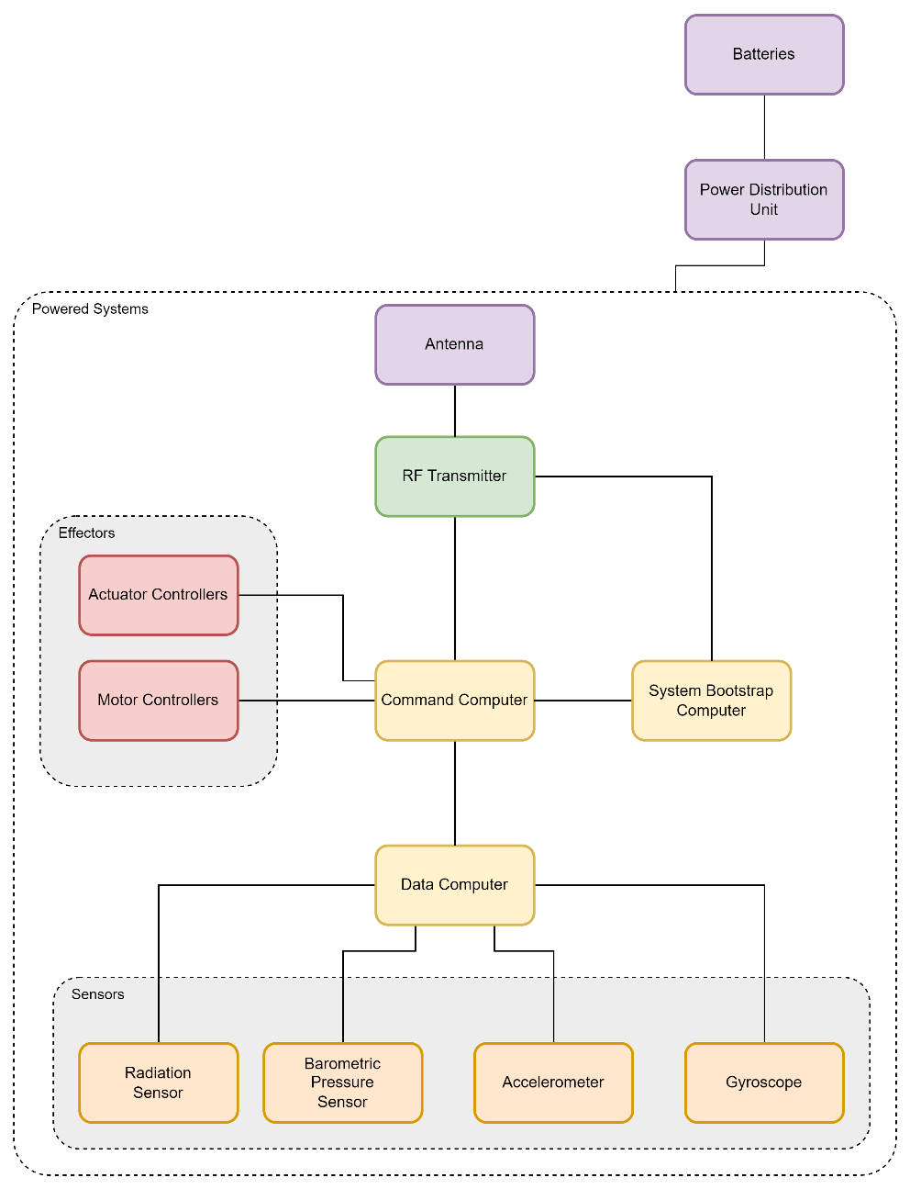
Figure 2. Hardware Architecture

<<Module 1>>

<<Module 2>>

System Software Architecture
<< In this section, describe the overall system software and organization. Include a list of software modules (this could include functions, subroutines, or classes), computer languages, and programming computer-aided software engineering tools (with a brief description of the function of each item). Use structured organization diagrams/object-oriented diagrams that show the various segmentation levels down to the lowest level. All features on the diagrams should have names. Include a narrative that expands on and enhances the understanding of the functional breakdown. If appropriate, use subsections to address each module. >>
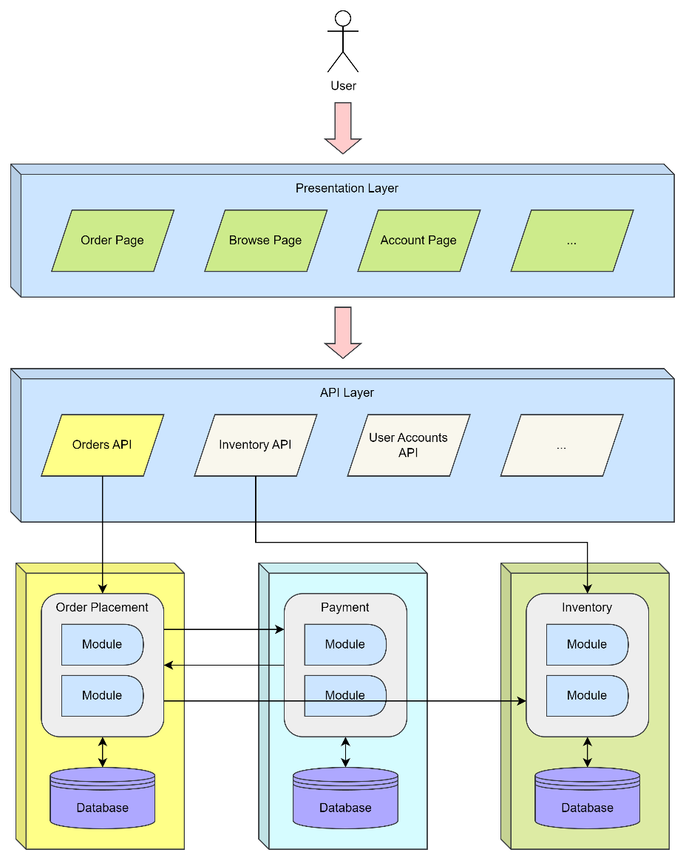
Figure 3. Software Architecture

<<Module 1>>

<<Module 2>>

Internal Communications Architecture
<< In this section, describe the overall communications within the system, for example: LANs, buses, etc. Include the communications architecture(s) being implemented, such as X.25, Token Ring, etc. Provide a diagram depicting the communications path(s) between the system and subsystem modules. If appropriate, use subsections to address each architecture being employed. >>

Human-Machine Interface (10%)
<< This section provides the detailed design of the system and subsystem inputs and outputs relative to the user/operator. Any additional information may be added to this section and may be organized according to whatever structure best presents the operator input and output design. Depending on the nature of the project, it may be appropriate to repeat these sections at both the subsystem and design module levels. Additional information may be added to the subsections if the suggested lists are inadequate to describe the project inputs and outputs. >>

Inputs
<< This section is a description of the input media used by the user for providing information to the system. In this section, show and describe a mapping to the high-level data flows described in Section 1.2.1, System Overview. For example, data entry dialog boxes, optical character readers, barcode scanners, etc. If appropriate, the input data types, file structures, and database structures may be referenced, or that could be left to a different section. Include data element definitions or create and refer to a data dictionary.
Provide the layout of all input data screens or graphical user interfaces (GUIs) (for example, windows, UI panels). Provide a graphical representation of each interface (an image). Define all data elements associated with each screen or GUI or reference the data dictionary.
This section should contain edit criteria for the data elements, including specific values, range of values, mandatory/optional, alphanumeric values, and length. Also address data entry controls to prevent edit bypassing.
Discuss the miscellaneous information associated with operator inputs, including the description of any access restrictions or security considerations. >>

Outputs
<< This section describes the system output design relative to the user/operator. In this section, show and describe a mapping to the high-level data flows described in Section 1.2.1. System Overview. For example, outputs include reports, data display dialogs and GUIs, query results, etc. The following should be provided, if appropriate:
- Identification of field names for reports and data display GUI elements
- Description of report and screen contents (provide a graphical (image) representation of each layout and define all data elements associated with the layout or reference the data dictionary)
- Description of the purpose of the output, including identification of the primary users
- Description of any access restrictions or security considerations >>

Detailed Design (30%)
<< This section provides the information needed for a system development team to completely build and integrate the hardware, program and integrate the software, and interconnect the hardware and software segments into a functional product. Additionally, this section addresses the detailed procedures for combining separate commercial off-the-shelf (COTS) (parts purchased from somewhere else and not made by the team) packages into a single system. Every subsystem itself and every detailed requirement should map back to the SRS. >>

Hardware Detailed Design
<< A hardware component is the lowest level of design granularity in the hardware system. Depending on the design requirements, there may be one or more components per system. This section should provide enough detailed information about individual component requirements to correctly build and/or procure all the hardware for the system (or integrate COTS items).
If there are many components or if the component documentation is extensive, place it in an appendix or reference a separate document. Add additional diagrams and information, if necessary, to describe each component and its functions adequately. Industry-standard component specification practices should be followed. For COTS procurements, if a specific vendor has been identified, include appropriate item names. Address the following information in the detailed component designs (as applicable):
- Power input requirements for each component
- Signal impedances and logic states
- Connector specifications (serial/parallel, 11-pin, male/female, etc.)
- Memory and/or storage space requirements
- Processor/Computing platform requirements (speed and functionality)
- Graphical representation depicting the number of hardware items (for example, monitors, servers, I/O devices, GPS modules), and the relative positioning of the components to each other
- Cable type(s) and length(s)
- User interfaces (buttons, toggle switches, etc.)
- Hard drive/Flash/SSD requirements
- Monitor resolution(s) >>

Software Detailed Design
<< A software module is the lowest level of design granularity in the software system. Depending on the software development approach, there will most likely be many modules per system. This section should provide enough detailed information about logic and data necessary to completely write source code for all modules in the system (and/or integrate existing software libraries).
If there is a long list of modules or if the module documentation is extensive, place it in an appendix or reference a separate document. Add additional diagrams and information, if necessary, to describe each module, its functionality, and its hierarchy. Industry-standard module specification practices should be followed. Include the following information in the detailed module designs:
- A narrative description of each module, its function(s), the conditions under which it is used (called or scheduled for execution), its overall processing, logic, interfaces to other modules, interfaces to external systems, security requirements, etc. Explain any complex algorithms used by the module in detail
- For existing software packages, specify how the system interfaces with the existing library
- Data elements, database structures, and file structures associated with module input and output
- Graphical representation of the design of the software module. This is usually done using a collaboration graph.
- Graphical representation of any complex algorithms used. This should be done using a common and readable standard such as a flow diagram.
- Data entry and data output graphics. Define or reference associated data elements. If the project is large and complex or if the detailed module designs will be incorporated into a separate document, then it may be appropriate to repeat some of the information in this section >>
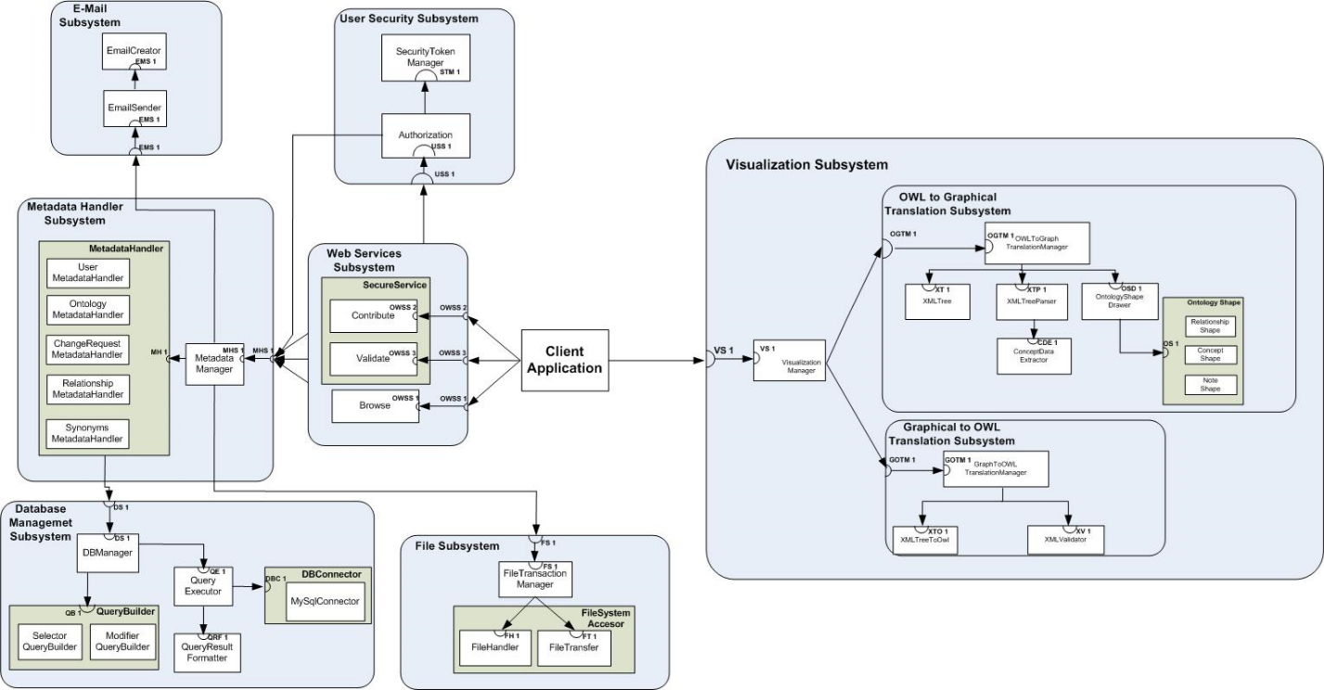
Figure 4. System collaboration graph
<< There would be text here to explain each subsystem of the system >>

Database Management Subsystem
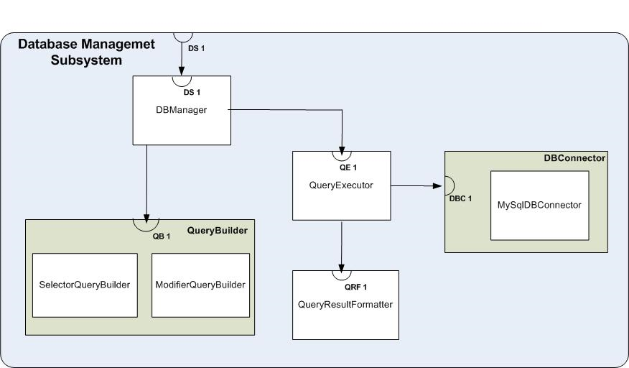
Figure 5. Collaboration graph for the Database Management Subsystem
<< The Database Management Subsystem has the following contracts that can be observed in Figure 5.
Contract <DS 1>: Query database
Server: Database Management Subsystem
Clients: Metadata Handler Subsystem
Description: This contract allows clients of contract to query the database in order to obtain specific information and receive a transformation of the results in a format compatible for the requestor of the contract.

Contract <QB 1>: Create SQL query
Server: QueryBuilder
Clients: DBManager
Description: This contract creates an SQL query that will be used by the DBManager to request the query’s execution.

Contract <QE 1>: Coordinate query execution
Server: QueryExecutor
Clients: DBManager
Description: This contract will allow the DBManager to execute a query through a pre-established database connection. After the result is obtained from the DBMS, the QueryExecutor will request the formatting of such result prior returning such information to the DBMS.

Contract <DBC 1>: Execute query
Server: DBConnector
Clients: QueryExecutor
Description: This contract will allow the execution of a query to a database regarding of the DBMS type.

Contract <QRF 1>: Transform results obtained from database
Server: QueryResultFormatter
Clients: QueryExecutor
Description: This contract will allow the QueryExecutor to request and receive a new formatted representation of the result obtained from executing a query. >>

Internal Communications Detailed Design
<< If the system includes more than one component there may be a requirement for internal communication to exchange information, provide commands, or support input/output functions. This section should provide enough detailed information about the communication design to correctly build and/or procure the communications components for the system. Include the following information in the detailed designs (as appropriate):
- The number of servers and clients to be included on each area network
- Specifications for bus timing requirements and bus control
- Format(s) for data being exchanged between components
- Graphical representation of the connectivity between components, showing the direction of data flow (if applicable), and approximate distances between components; information should provide enough detail to support the procurement of hardware to complete the installation at a given location
- LAN topology >>

External Interfaces (10%)
<< External systems are any systems that are not within the scope of the system under development. This can include certain software such as external databases, or external hardware such as sensors, motor controllers, etc. In this section, describe the electronic or software interface(s) between this system and each of the other systems and/or subsystem(s). >>

Hardware Interface Architecture
<< In this section, describe the hardware interface(s) between the system being developed and other systems. For example: UART, I2C bus, CAN bus, Ethernet, etc. Include the interface architecture(s) being implemented, such as wide area networks, gateways, etc. Provide a diagram depicting the communications path(s) between this system and each of the other systems, which should map to the context diagrams in Section 1.2.1. If appropriate, use subsections to address each interface being implemented. >>

Hardware Interface Detailed Design
<< For each hardware system that provides information exchange with the system under development, there is a requirement for rules governing the interface. This section should provide enough detailed information about the interface requirements to correctly format, transmit, and/or receive data across the interface. Include the following information in the detailed design for each interface (as appropriate):
- The data format requirements. If there is a need to reformat data before they are transmitted or after incoming data is received, tools and/or methods for the reformat process should be defined
- Specifications for hand-shaking protocols between the two systems; include the content and format of the information to be included in the hand-shake messages, the timing for exchanging these messages, and the steps to be taken when errors are identified
- Format(s) for error reports exchanged between the systems. This should address the presentation format of errors. For example, a buzzer, an LED, a message sent to the software, etc.
- Graphical representation of the connectivity between systems, showing the direction of data flow
If a formal Interface Control Document (ICD) exists for a given interface, the information can be copied, or the ICD can be referenced in this section. >>

Software Interface Architecture
<< In this section, describe the software interface(s) between the system being developed and other systems. For example: HTTP, web sockets, shared memory, UDP, etc. Include the interface architecture(s) being implemented, such as federations, gateways, etc. Provide a diagram depicting the communications path(s) between this system and each of the other systems, which should map to the context diagrams in Section 1.2.1. If appropriate, use subsections to address each interface being implemented. >>

Software Interface Detailed Design
<< For each software system that provides information exchange with the system under development, there is a requirement for rules governing the interface. This section should provide enough detailed information about the interface requirements to correctly format, transmit, and/or receive data across the interface. Include the following information in the detailed design for each interface (as appropriate):
- The data format requirements. If there is a need to reformat data before they are transmitted or after incoming data is received, tools and/or methods for the reformat process should be defined
- Specifications for hand-shaking protocols between the two systems; include the content and format of the information to be included in the hand-shake messages, the timing for exchanging these messages, and the steps to be taken when errors are identified
- Format(s) for error reports exchanged between the systems. This should address the presentation format of errors. For example, an alert dialog, a UI element changing, a sound playing, etc.
- Graphical representation of the connectivity between systems, showing the direction of data flow
- Query and response descriptions
If a formal Interface Control Document (ICD) exists for a given interface, the information can be copied, or the ICD can be referenced in this section. >>

System Integrity Controls (10%)
<< Sensitive systems use information for which the loss, misuse, modification of, or unauthorized access to that information could affect the operation of an organization, or the privacy to which individuals are entitled.
Developers of sensitive systems are required to develop specifications for the following minimum levels of control:
- Internal security to restrict access of critical data items to only those access types required by users
- Audit procedures to meet control, reporting, and retention period requirements for operational and management reports
- Verification processes for additions, deletions, or updates of critical data >>

Note: If based on your project, a section would not be applicable, and/or the section would require minimum content, then the grade percentage for that section, will be evenly distributed to other section of the document.

